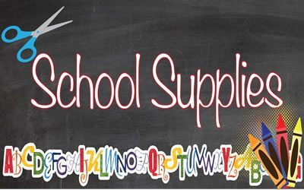

**\*\*Please label everything with your child’s name\*\***

* **Full size book bag**

The small book bags are adorable, but your little one will need a big book bag. They will need room for folders, sheets, blankets, lunch boxes, clothing, etc.  The small ones just won’t fit everything!

* **Mat for nap time**
* **Fitted sheet to cover the mat**
* **Blanket for child to cover up with**
* **Supply/pencil box with the following included (crayons, pencils, markers etc.)**
* **Two sets of extra clothing**

Shirt, pants, socks, and underwear constitutes a full set of clothing.  Please place each set in a gallon-size zip loc bag with your child’s name labeled on it.  When the weather begins to change, we will send the extra clothing home so that more appropriate clothing can be exchanged.

**\*Water Bottle (Optional)**